COULD COMPUTING AND BIG DATA ANALYTICS

EXP 1:

Create a simple cloud software application and provide it as a service using any Cloud Service Provider to demonstrate Software as a Service (SaaS).

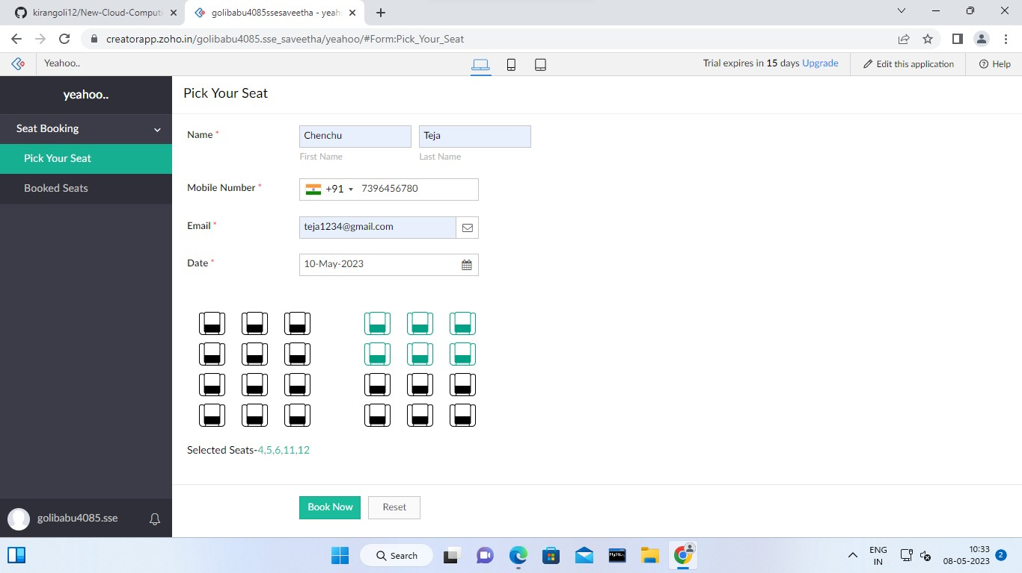

EXP 2:

Create a Virtual Machine with 1 vCPU, 2GB RAM and 15GB storage disk using a Type 2 Virtualization Software.

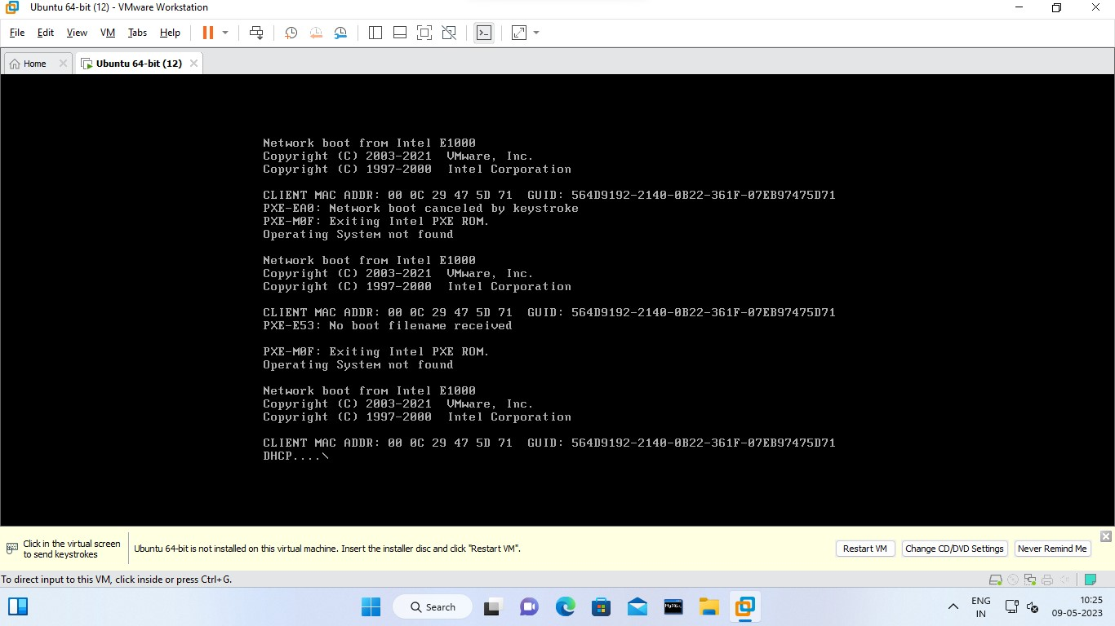

EXP 3: Create a Virtual Hard Disk and allocate the storage using VM ware Workstation

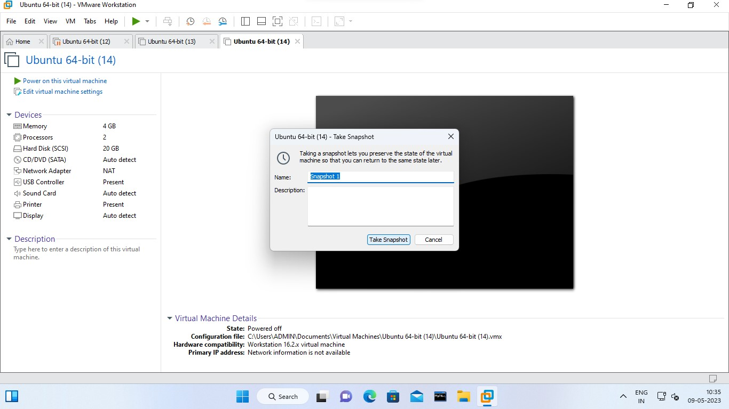

EXP 4:

Create a Snapshot and Cloning of a VM and Test it by loading the Previous Version/Cloned VM

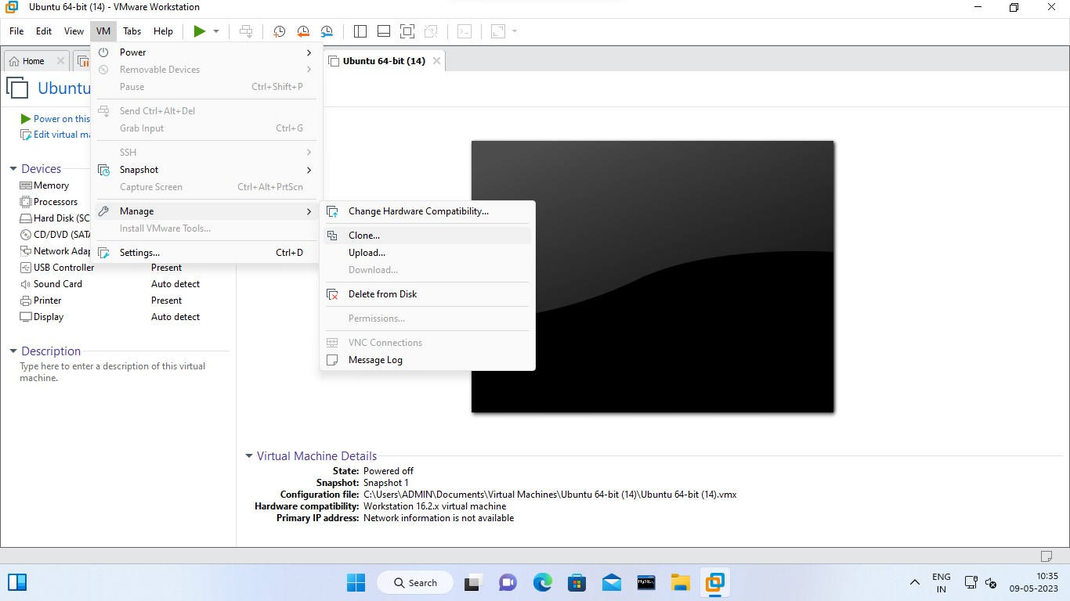

EXP 5:

Demonstrate Infrastructure as a Service (IaaS) by Creating a Virtual Machine using a Public Cloud Service Provider (Azure/GCP/AWS), configure with minimum CPU, RAM, and Storage and Launch the VM image

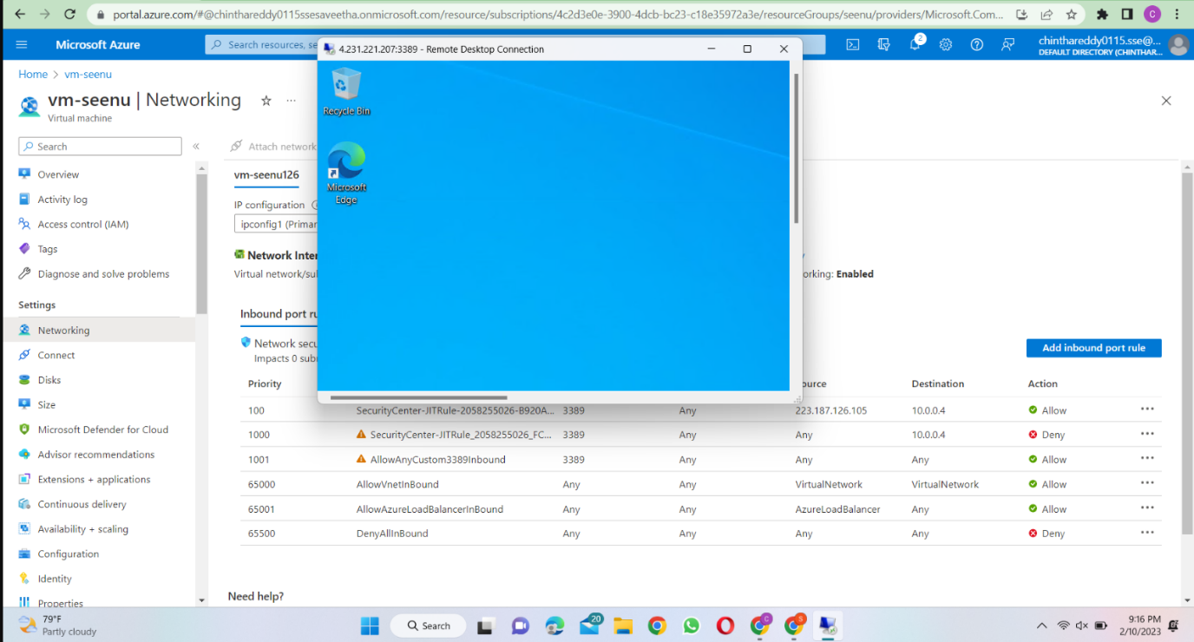

EXP 6:

Create a Simple Web Application using Java or Python and host it in any Public Cloud Service Provider (Azure/GCP/AWS) to demonstrate Platform as a Service

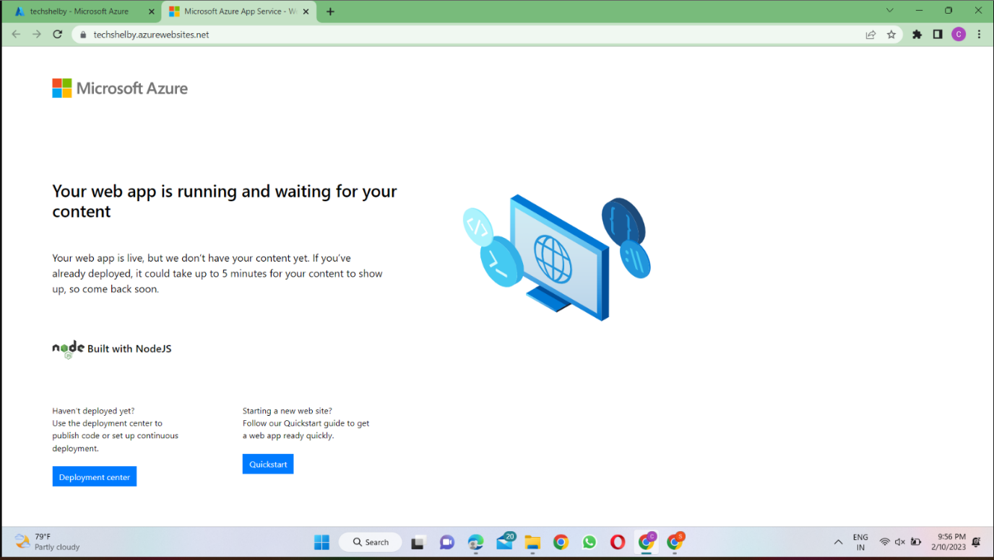

EXP 7:

Create a Storage service using any Public Cloud Service Provider (Azure/GCP/AWS) and check the public accessibility of the stored file to demonstrate Storage as a service.

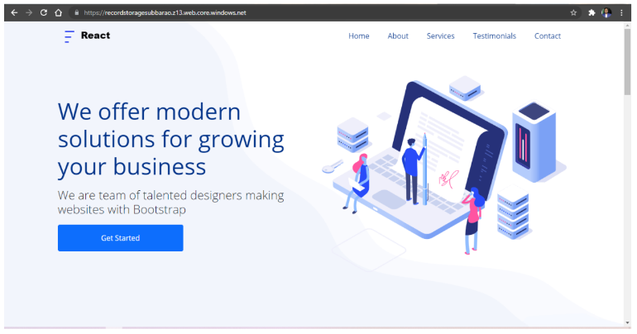

EXP 8:

Create a SQL storage service and perform a basic query using any Public Cloud Service Provider (Azure/GCP/AWS) to demonstrate Database as a Service (DaaS)

